Crisis UK
London
Dear Sir/Madam,

Will you help the homeless this Winter?

Thomas lives on the streets. He is twelve years old with no food or shelter, only a sleeping bag and a few bits of cardboard. He spends his days and nights scared, cold and begging for money. He doesn’t get very much, typically earning £1 a day which is barely enough to buy a small bottle of water. Is this a good life for a twelve year old boy?

You can help change this boy’s life and the lives of many other children like him. Giving two pounds a month, only a little more than he earns in a day, could make all the difference. We’re Crisis and we are committed to helping improve the lives of homeless people, as we have been since the charity was set up in
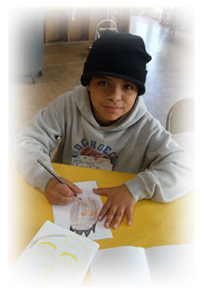
One month ago, a young Polish boy of about seven years old was found by out team of volunteers on the streets alone. He was taken in by us and lived in a children’s home for a year. He couldn’t speak English and his mother was a drug addict but with our help and support he found his mother again, he learnt a reasonable level of spoken English and made friends. Crisis also helped his mother to overcome her heroin addiction. Without us, that little boy would most likely be dead by now and his mother would be continuing to channel her life down a narrow tunnel of lethal addiction and poverty.

Readers, you wake up every morning in a warm bed, use your own, private shower and eat hot food for dinner, especially at Christmas. These are all things you take for granted. Homeless street sleepers can’t use their own private bathroom or spend time with their family at Christmas eating hot food, which is why they rely on centres like us, Crisis, to provide for them. We cannot keep doing that without your help and continued donations.

Please, give £2 a month.

Thank you,

I Long

Isabell Long
Director, Crisis UK.

